|  |  |
| --- | --- |
| Course name:  Diploma in Software and Design | |
| Assignment title | **DSD-04 Agile Group Project** |
| Assessment weighting | *Need to pass the assessment to complete the course* |
| Passing Criteria: | Need to score 50% or more to pass the assessment.  **Total Marks: 100** |
| Due date: | **Your Tutor will advise you**  (late submissions incur 10% penalty, after 7 days late, the assessment will not be marked) |
| Assessment conditions: | This is a resource-based assessment. This means that you may have access to any relevant resources to assist you.  This could include your learning materials, information on the Internet, and so on. However, all work must be your own with no assistance from any other person. |
| Submission requirements: | Upload your project to Github or Cloud Campus |
| Module Names and Learning Outcomes | **Project Management**   * 1. Identify requirements and implement mobile solutions * 2. Conduct project planning activities that accurately forecast project costs, timelines, and quality. Implement processes for successful resource, communication, and risk and change management. * 3. Use an appropriate methodology for project management * 4. Demonstrate effective project execution and control techniques that result in successful projects * 5. Satisfy client expectations and meet client needs in executing a software development project |

This is an **ONLINE** only assessment. No paperwork is needed.

**Disclaimer of Plagiarism and Collusion**

I declare that:

* I have read and understood the ATC Vision Collage “Assessment Policy” and “Academic Cheating” sections as described in the Student Handbook.
* I am aware of the penalties for cheating as described in the Student Handbook.
* This assessment submission is entirely my own work, I have quoted, referenced and acknowledged any work copied directly from another source.
* I understand this assessment submission may be used for internal and/or external moderation.

I understand that if I have circumstances that affect my progress to complete assessment tasks, I will discuss it with my tutor prior to submission date

# Navdeep Kaur

# Agile Group Project

## Objective

The students are required to undertake a group project as part of their Assessment for the Diploma in Software Engineering and Design qualification. The students are required to build an Android app using Agile methodologies. The App will also use a Source Control system such as Git.

## Purpose

The purpose of the assessment is to create an Android App using Agile and Scrum methodologies.

The intention is that all group projects should be successful, and all students are expected to contribute to their own project in accordance with the timetable.

Group projects are expected to take students 180 hours of work per student, spread over 6 to 7 weeks, and to enable students to display their understanding across a broad range of subjects.

Groups will be expected to exhibit professional skills in design, quality and management. Specifically, they will have to show that the work has been carefully planned, that components and systems have been properly tested, and that members of the group have cooperated effectively.

The exercise also gives students experience of working against deadlines, with a team of colleagues. This gives some idea of the problems encountered in normal professional practice.

The review meetings provide an opportunity to monitor group progress and for general discussion. Your tutor will attend all the review meetings.

### Requirements

Create a mobile app using Agile and Scrum methodologies. The final app may not be totally finished owing to time constraints. But still be operatable.

## Final deliverables

Copy and paste the questions below into a new document, answer them, and put it in your assessment folder with a copy of the app.

**Answer the following questions.**

What was the App that your group created?

**Inventory management system**

### Agile / Scrum

1. What did you learn about how the Agile and Scrum methodologies operate?

Agile scrum approach is an incremental development-based project management technique. There are two- to four-week sprints in each iteration, where each sprint is meant to develop the main features first and to come up with a product that is theoretically usable. In following sprints, new features will be integrated into the product and tailored to stakeholder and consumer input.

Whereas other types of project management priorities creating a whole system from beginning to end in one iteration, agile scrum processing concentrates on the provision of multiple product iterations to give customers the greatest market benefit in the least time possible.

Methodology of agile scrum has significant advantages. Second, it promotes the construction of goods more efficiently, as each set of tasks has to be accomplished within the time span of each sprint. It also calls for regular preparation and targeting, allowing the scrum team to concentrate on the goals of the current sprint and improve efficiency.

The following agile approaches share the same general philosophy, as well as many of the same functions and procedures. However, it has its own particular combination of procedures, terms and strategies. From the execution point of view.

The Agile methodologies most often used include:

* Methodology for Agile Scrum
* Creation of Lean Apps
* Kanban
* Extremely programmable
* Crystalline
* Method for designing complex processes
* Creation of feature oriented

The Scrum methodology calls for the team to gather at the outset of the sprint, where it can learn how many things it will contribute to and then create a backlog for the sprint – a list of activities to be carried out during the sprint. The Scrum team takes a few attributes from theories to coded and checked features during an agile Scrum sprint. At the end, the feature is finished, which ensures that the product or device is programmed, checked and integrated. Compare this to the conventional project management processes in which stakeholder input and time spent modifying the product in the middle of production – or worse the teams must start from scratch after the plan has been manufactured. A scrum advisor in the business or an external scrum expert should be presented to ensure the proper implementation of scrum concepts to incorporate the agile scrum approach. Agile scrum technique means precision execution which unless properly executed, may lead to a tragedy.

1. In practice how effective did you find this methodology?

Agile scrum technique has many advantages. Second, it allows goods to be developed quicker, as each series of targets must be achieved within each sprint's time span. It takes regular preparation and targeting to allow the scrum team to concentrate on the goals of the current sprint and improve efficiency.

* Scrum is a system that helps teams collaborating on challenging tasks to collaborate more efficiently.
* Agile and scrum, with a few main distinctions, are two identical project management frameworks.
* Agile is more flexible and encourages management team, while scrum is stiffer and encourages cross-functional teams.

Agile is developmental, offering teams with each new iteration or draught a chance to learn. Agile helps teams to deliver a prototype and refine it with each cycle. Teams can more easily address changing goals. Productivity is improved by this fast and scalable operation.

Scrum defines a series of workshops, instruments, and tasks that work in concert to help teams’ structure and organize their work, often thought of as an agile project management system. Because of its simplicity and high performance, Scrum is the most common Agile project management system. In a collaboration environment, it takes advantage of a desire for a sense of success, constructive feedback, and control of work completed.

1. What did you find was the strength of it?

High level of project flexibility. Fast periods and continuous revisions allow you to frequently adapt your project and customize it at any time to the needs of the client. In delivering a complete project that would be refused by the client, you don't have to waste your time and money. This makes the method of production incredibly versatile.

High customer satisfaction during the process of growth. Since Agile projects are tightly coordinated with the client, the implementation project has a direct influence on the customer. In short periods, programme components are distributed continually and the input of the consumer is often taken into account.

Constant interaction with the stakeholders. You stop creating lots of technical documents, procedures, and instruments with the departments actively communicating with each other and with the client. Each participant feels like a big part of the team involved in the process of decision-making. This encourages ingenuity and effort and leads in better outcomes.

Continuous promise of consistency, attention to information. Product consistency can be maintained from the early stages of Agile development by the research staff. As the construction is carried out in short periods, research is done non-stop, helping you to deliver a successful finished product.

Scrum can help teams easily and successfully complete project deliverables.

* Scrum can assist teams to efficiently and easily complete project deliverables
* Scrum guarantees that time and resources are spent efficiently.
* Wide projects are broken into simple to execute sprints.
* Developments after the sprint analysis are coded and tested
* Works well on fast-moving initiatives for growth
* Using scrum sessions, the squad gets strong exposure
* Scrum adopts input from clients and customers, is agile,
* Quick sprints make for even simpler improvements based on feedback.
* A team member's individual contribution is evident at regular scrum meetings.

1. What were its weaknesses?

Problems of organization of workflows. Several small teams working on their own pieces of software are interested with Agile projects. For each other, testers and administrators, they should still organize their job. Connect to the constant client contact, and before launching the job, you'll have a lot of system development to remember. Although a lot of contact is considered a benefit of Agile technique, due to several reasons, it can become a weak point.

Difficult early-stage preparation. Agile production preparation is important before beginning the process. Before it is released, it is important to analyses the finances, create teams and articulate an overarching view of the project to them.

Teams with professionals are vital. Agile ventures need teams to continually make serious choices. It means that the project can only be worked on by professional software engineers, reviewers, and administrators. This technique for software creation gives very few positions for rookies.

Lack in planning for the long-term. In certain situations, a lack of final vision of the project could be disorganizing. Your project can end up off track if the customer changes his mind too much during the process. And note, you're going to have to assemble all the bits of software that have been updated and adapted a million times during the production period by the end of the project to make them functional. There would also be inadequate reporting, as the consumer communications were mainly verbal.

Nothing is flawless, and no exception is the Scrum technique. In certain instances, Scrum is paired with other methods for managing projects that can help overcome some of these disadvantages:

* Owing to the absence of a fixed end date, Scrum also contributes to scope creep.
* When people are not really dedicated or cooperative, the risks of project failure are high.
* The implementation of the Scrum system in large teams is complex.
* Only with experienced team members will the system be effective.
* Regular meetings will frustrate members of the team at times.
* If every team member exits in the midst of a project, the effect on the project will be enormously detrimental.
* Until the team goes through an aggressive testing process, consistency is difficult to enforce.

1. What were the best features of the process?

The attributes of agile technique that I think are strongest are described as follows:

* Flexibility on top of agility.
* Project accountability attributable to agility.
* Efficiency with the agile technique.

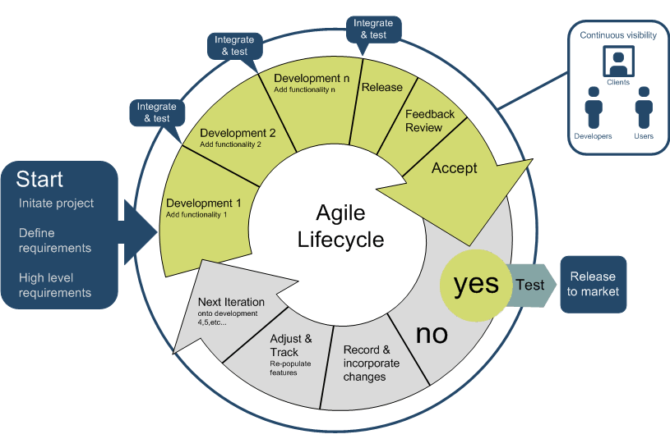

* Sprints: It is a recursive production cycle, whereby the breaking down the work into tiny and digestible chunks, specifications are optimized periodically.
* Scrum Meetings: The team's working environment is strongly collaborative.
* The agile growth process results in a 'inspect and change' strategy by periodically updating products and services with various stakeholders.
* The agile growth process results in a 'inspect and change' strategy by periodically updating items / solutions with internal and external stakeholders.
* The straightforward method can be implemented through online Agile Project Management platforms such as Team Base Service, Jira, Trello, Kanbanzie, and others because of open contact with partners and other shareholders and project management processes.

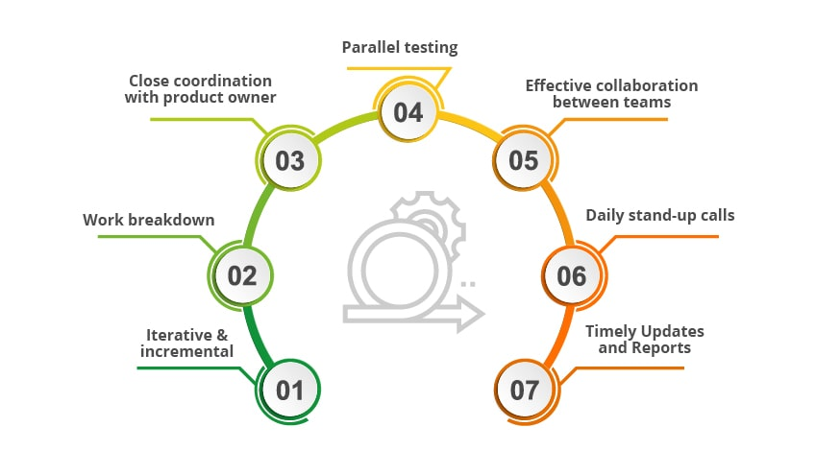

# Iterative & incremental:

In order to make the product stronger, the agile framework recommends a gradual and iterative approach with periodic reassessments.

# Breakdown of Work:

Technically known as sprints or scrum, the agile process consists of short loops. This means splitting the project work into iterations or sprints.

# Near cooperation with the owner of a product:

The owner or client of the product has a first-hand description of each level of project creation, along with improvements, if any.

# Checking in parallel:

The production of software and the review of software was carried out in tandem to ensure the distribution of quality software. Regression testing takes place every time new features or logic are implemented.

# Successful team-to-team collaboration:

In contrast to the earlier waterfall paradigm, testers and developers work in close partnership.

# Daily calls for stand-ups:

Every day, brief and fast meetings are arranged as stand-up calls to discuss the progress of activities within the agile process.

1. How did they appeal to you?

These features appeal to me as they make my customer feel relaxed with the task, as these features tend to include the client with all of the application's creation process. Which contribute to reach the satisfaction of the customer.

1. What was the worst feature of the process?

Although programme specifications are explained only in time for development, documentation is less comprehensive. This suggests that they don't know the specifics of such features or how they need to work as new people join the team. This causes misunderstandings and problems. Developers do not measure the full scope of the necessary commitment for such app deliverables. This is particularly true for bigger goods at the beginning of the production life cycle. These unknowns are dreaded by teams new to agile methodology. This fear fuels rage, bad policies, and sometimes bad choices. The more controlled waterfall approach makes it easier to measure the commitment, time and expense of producing the finished product. Since software specifications are clarified only in time for production, less comprehensive documentation is given. This suggests that they don't know the specifics of such features or how they need to work as new people join the team.

1. How would you change them?

I think we can make a mind mapping for this system to overcome the problems.

### Group work

1. What did you enjoy about this style of programming?

The pleasure of making things that is helpful to other people. One of the most rewarding facets of the job as a programmer is to see code that you wrote implemented in a live environment and used by real people, particularly if both the user and the developer better their lives in some way and features and success in the project.

1. What are the downsides for you of group work?

When working as a group, this approach disturbs the job flow, which appears to be more annoying. It may build disagreements between members. In a team, mixed with poor coordination, if we have multiple identities clashing, you will certainly see conflicts emerging.

1. How did this session change your opinion of working in industry?

It persuades my mind to be willing to achieve a goal that s personal sets.This sessions changed my opinion, when I became conscious of the fact that working in the industry to deal with technological and complicated challenges in a realistic atmosphere is not as easy for the client.

### Source Control

1. What form of Source Control did you use?

We have use “Github”;

1. What were its strengths?

1. Contributing to the open-source projects makes it possible to

2. Documentation Inside

3. Showcasing the work

4. With Markdown

5. GitHub is a software repository.

6. Track the code changes across versions

1. What were its weaknesses?

* GIT requires technical excellence and on windows it is slower.
* They have bad accessibility and GUIs.
* GIT doesn't help sub-trees logging out.
* It lacks support for a window and doesn't monitor empty files.
* In order to facilitate concurrent developments used by users, GIT requires several branches.
* The privacy of GitHub.
* Pricing of the functions.

1. How effective as a source control did you find it?

Since this helps to quickly handle the software iterations that can be seamlessly combined with any cloud. Click or download the Cloning button and copy the HTTPS connection. Now open RStudio, press File/New Project/Version control/Git, and paste the HTTPS link into the Repository URL: field from the GitHub repository.

1. If you had to use it again what would you change?

I will change all the drawbacks of the GitHub.

### Other

1. Do you feel that this has been a worthwhile experiment?

Yes.

1. Why? Why not?

As it allows me to gain realistic knowledge of the agile creation of applications, I found it worth experimenting with, and I developed many applications related to the agile software.

1. **If you had to give yourself a percent grade for your contribution to the project, and the process, what would it be?** Bearing in mind that you might have produced little, yet done the hard yards. Or you made heaps, but it was really easy.

I would like to give me an award because the work I demonstrate is little, but the devotion to this little achievement is overwhelming.